**Lab 2: Shopping Site**

**R. Harini 18BCE1010**

**Prof. Sandhya P**

**Code:**

**Main Page:**

<html>

<head><title>My shopping Webpage</title></head>

<frameset cols="400,*">

<frame src="Menu.html" name="frame1">

<frame src="Blank.html" name="frame2">

</frameset>

</html>

**Menu:**

<html>

<head><title>My Shopping webpage</title></head>

<body background="BG.jpg">

<br>

<h1><font face="Courier New" size=10 >AboutTheFit</font></h1>

<font face="Verdana" size=5><br><br>

<h3>Elevate your lifestyle by shopping on our website!</h3><br><br>

</font>

<ul><b><font size=5 face='Verdana'>

<li><a href="Books.html" target="frame2">Show Books</a></li>

<li><a href="Gadgets.html" target="frame2">Show Gadgets</a></li></b>

</ul>

</font>

</body>

</html>

**Books:**

<html>

<head><title>Books</title></head>

<body bgcolor="red"><br>

<font face='Times Roman' size=5><h1 align='center'>Books Available</h1></font><br>

<button><font size=5 align='right'><a name="top" href="#bottom" >Go to bottom</a></font></button>

<br><br>

<style>

.zoom {

padding: 50px;

transition: transform .2s; /* Animation */

margin: 0 auto;

}

.zoom:hover {

transform: scale(1.5); /* (150% zoom - Note: if the zoom is too large, it will go outside of the viewport) */

}

</style>

<table>

<tr height>

<td align="center" style="height:400px; width:300px"><img class="zoom" src="Harry Potter.jpg"><figcaption><b>Harry Potter</b></figcaption><figcaption>Rs.599</figcaption></td>

<td align="center" style="height:400px; width:300px"><img class="zoom" src="A Thousand Splendid Suns.jpg"><figcaption><b>A Thousand Splendid Suns</b></figcaption><figcaption>Rs.399</figcaption></td>

<td align="center" style="height:400px; width:300px"><img class="zoom" src="The Kite runner.jpg"><figcaption><b>The Kite Runner</b></figcaption><figcaption>Rs.399</figcaption></td>

<td align="center" style="height:400px; width:300px"><img class="zoom" src="Hunger Games.jpg"><figcaption><b>Hunger Games</b></figcaption><figcaption>Rs.499</figcaption></td>

<td align="center" style="height:400px; width:300px"><img class="zoom" src="Catching fire.jpg"><figcaption><b>Catching Fire</b></figcaption><figcaption>Rs.499</figcaption></td>

</tr>

<tr>

<td align="center" style="height:400px; width:300px"><img class="zoom" src="Mockingjay.jpg"><figcaption><b>Mockingjay</b></figcaption><figcaption>Rs.499</figcaption></td>

<td align="center" style="height:400px; width:300px"><img class="zoom" src="A Thousand Splendid Suns.jpg"><figcaption><b>A Thousand Splendid Suns</b></figcaption><figcaption>Rs.399</figcaption></td>

<td align="center" style="height:400px; width:300px"><img class="zoom" src="Catching fire.jpg"><figcaption><b>Catching Fire</b></figcaption><figcaption>Rs.499</figcaption></td>

<td align="center" style="height:400px; width:300px"><img class="zoom" src="Harry Potter.jpg"><figcaption><b>Harry Potter</b></figcaption><figcaption>Rs.599</figcaption></td>

<td align="center" style="height:400px; width:300px"><img class="zoom" src="Hunger Games.jpg"><figcaption><b>Hunger Games</b></figcaption><figcaption>Rs.499</figcaption></td>

</tr>

<tr>

<td align="center" style="height:400px; width:300px"><img class="zoom" src="Hunger Games.jpg"><figcaption><b>Hunger Games</b></figcaption><figcaption>Rs.499</figcaption></td>

<td align="center" style="height:400px; width:300px"><img class="zoom" src="Catching fire.jpg"><figcaption><b>Catching Fire</b></figcaption><figcaption>Rs.499</figcaption></td>

<td align="center" style="height:400px; width:300px"><img class="zoom" src="Mockingjay.jpg"><figcaption><b>Mockingjay</b></figcaption><figcaption>Rs.499</figcaption></td>

<td align="center" style="height:400px; width:300px"><img class="zoom" src="A Thousand Splendid Suns.jpg"><figcaption><b>A Thousand Splendid Suns</b></figcaption><figcaption>Rs.399</figcaption></td>

<td align="center" style="height:400px; width:300px"><img class="zoom" src="The Kite runner.jpg"><figcaption><b>The Kite Runner</b></figcaption><figcaption>Rs.399</figcaption></td>

</tr>

</table>

<button><font size=5 align='right'><a name="bottom" href="#top" >Go to top</a></font></button>

</body>

</html>

**Clothes:**

<html>

<head><title>Clothes</title></head>

<body bgcolor="red">

<h1 align='center'>Clothes available</h1>

<a name="top" href="#bottom" align='right'>Go to bottom</a>

<table>

<tr height>

<td align="center"><img src="Tops.jpg"><figcaption><b>Harry Potter</b></figcaption><figcaption>Rs.599</figcaption></td>

<td align="center"><img src="A Thousand Splendid Suns.jpg"><figcaption><b>A Thousand Splendid Suns</b></figcaption><figcaption>Rs.399</figcaption></td>

<td align="center"><img src="The Kite runner.jpg"><figcaption><b>The Kite Runner</b></figcaption><figcaption>Rs.399</figcaption></td>

<td align="center"><img src="Hunger Games.jpg"><figcaption><b>Hunger Games</b></figcaption><figcaption>Rs.499</figcaption></td>

<td align="center"><img src="Catching fire.jpg"><figcaption><b>Catching Fire</b></figcaption><figcaption>Rs.499</figcaption></td>

</tr>

<tr>

<td align="center"><img src="Mockingjay.jpg"><figcaption><b>Mockingjay</b></figcaption><figcaption>Rs.499</figcaption></td>

<td align="center"><img src="A Thousand Splendid Suns.jpg"><figcaption><b>A Thousand Splendid Suns</b></figcaption><figcaption>Rs.399</figcaption></td>

<td align="center"><img src="Catching fire.jpg"><figcaption><b>Catching Fire</b></figcaption><figcaption>Rs.499</figcaption></td>

<td align="center"><img src="Harry Potter.jpg"><figcaption><b>Harry Potter</b></figcaption><figcaption>Rs.599</figcaption></td>

<td align="center"><img src="Hunger Games.jpg"><figcaption><b>Hunger Games</b></figcaption><figcaption>Rs.499</figcaption></td>

</tr>

<tr>

<td align="center"><img src="Hunger Games.jpg"><figcaption><b>Hunger Games</b></figcaption><figcaption>Rs.499</figcaption></td>

<td align="center"><img src="Catching fire.jpg"><figcaption><b>Catching Fire</b></figcaption><figcaption>Rs.499</figcaption></td>

<td align="center"><img src="Mockingjay.jpg"><figcaption><b>Mockingjay</b></figcaption><figcaption>Rs.499</figcaption></td>

<td align="center"><img src="A Thousand Splendid Suns.jpg"><figcaption><b>A Thousand Splendid Suns</b></figcaption><figcaption>Rs.399</figcaption></td>

<td align="center"><img src="The Kite runner.jpg"><figcaption><b>The Kite Runner</b></figcaption><figcaption>Rs.399</figcaption></td>

</tr>

</table>

<a name="bottom" href="#top" align='right'>Go to top</a>

</body>

</html>

**Gadgets:**

<hmtl>

<head><title>Gadgets</title></head>

<body bgcolor="red"><br>

<font face='Times Roman' size=5><h1 align='center'>Gadgets Available</h1></font><br>

<button><font size=5 align='right'><a name="top" href="#bottom" >Go to bottom</a></font></button>

<br><br>

<table>

<tr>

<td align="center" style="height:300px; width:300px"><img src="Apple Watch.jpg" height="200" width="200"><figcaption><b>Apple Watch Series 4</b></figcaption><figcaption>Rs.45,999</figcaption></td>

<td align="center" style="height:300px; width:300px"><img src="Laptop.jpg" height="200" width="200"><figcaption><b>ThinkPad lenovo</b></figcaption><figcaption>Rs.89,999</figcaption></td>

<td align="center" style="height:300px; width:300px"><img src="Samung gear Sport.jpg" height="200" width="200"><figcaption><b>Samsung Gear Sport</b></figcaption><figcaption>Rs.12,999</figcaption></td>

<td align="center" style="height:300px; width:300px"><img src="Watches.jpg" height="200" width="200"><figcaption><b>Rolex Watch</b></figcaption><figcaption>Rs.1,499</figcaption></td>

<td align="center" style="height:300px; width:300px"><img src="G-Shock.jpg" height="200" width="200"><figcaption><b>G-Shock</b></figcaption><figcaption>Rs.14,499</figcaption></td>

</tr>

<tr>

<td align="center" style="height:300px; width:300px"><img src="Mobiles.jpg." height="200" width="200"><figcaption><b>OnePlus 7T</b></figcaption><figcaption>Rs.34,499</figcaption></td>

<td align="center" style="height:300px; width:300px"><img src="A Thousand Splendid Suns.jpg" height="200" width="200"><figcaption><b>A Thousand Splendid Suns</b></figcaption><figcaption>Rs.399</figcaption></td>

<td align="center" style="height:300px; width:300px"><img src="Catching fire.jpg" height="200" width="200"><figcaption><b>Catching Fire</b></figcaption><figcaption>Rs.499</figcaption></td>

<td align="center" style="height:300px; width:300px"><img src="Harry Potter.jpg" height="200" width="200"><figcaption><b>Harry Potter</b></figcaption><figcaption>Rs.599</figcaption></td>

<td align="center" style="height:300px; width:300px"><img src="Hunger Games.jpg" height="200" width="200"><figcaption><b>Hunger Games</b></figcaption><figcaption>Rs.499</figcaption></td>

</tr>

<tr>

<td align="center" style="height:300px; width:300px"><img src="Hunger Games.jpg" height="200" width="200"><figcaption><b>Hunger Games</b></figcaption><figcaption>Rs.499</figcaption></td>

<td align="center" style="height:300px; width:300px"><img src="Catching fire.jpg" height="200" width="200"><figcaption><b>Catching Fire</b></figcaption><figcaption>Rs.499</figcaption></td>

<td align="center" style="height:300px; width:300px"><img src="Mockingjay.jpg" height="200" width="200"><figcaption><b>Mockingjay</b></figcaption><figcaption>Rs.499</figcaption></td>

<td align="center" style="height:300px; width:300px"><img src="A Thousand Splendid Suns.jpg" height="200" width="200"><figcaption><b>A Thousand Splendid Suns</b></figcaption><figcaption>Rs.399</figcaption></td>

<td align="center" style="height:300px; width:300px"><img src="The Kite runner.jpg" height="200" width="200"><figcaption><b>The Kite Runner</b></figcaption><figcaption>Rs.399</figcaption></td>

</tr>

</table>

<button><font size=5><a name="bottom" href="#top" align='right'>Go to top</a></font></button>

</body>

</hmtl>

**Screenshots:**

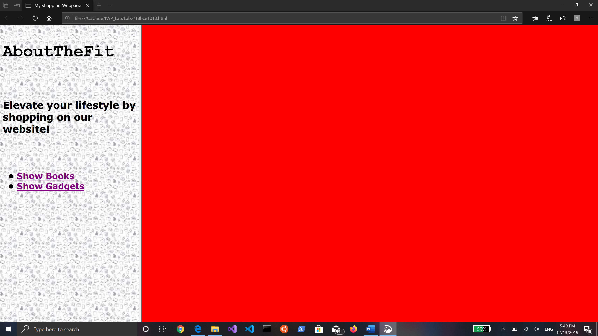

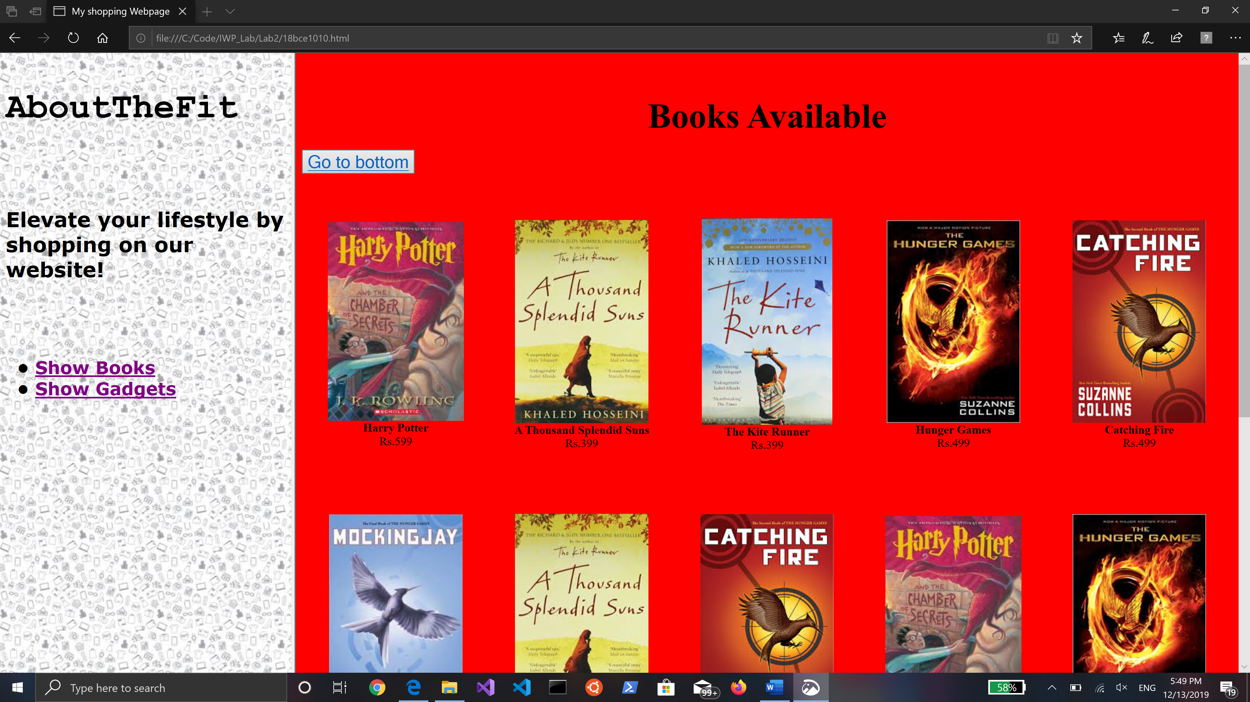

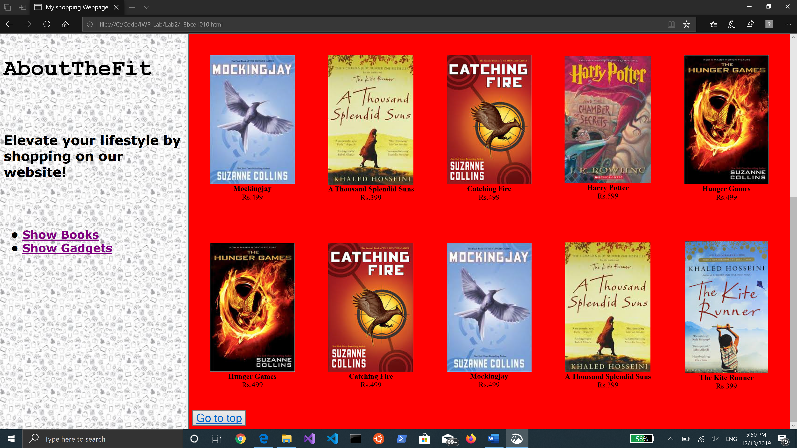

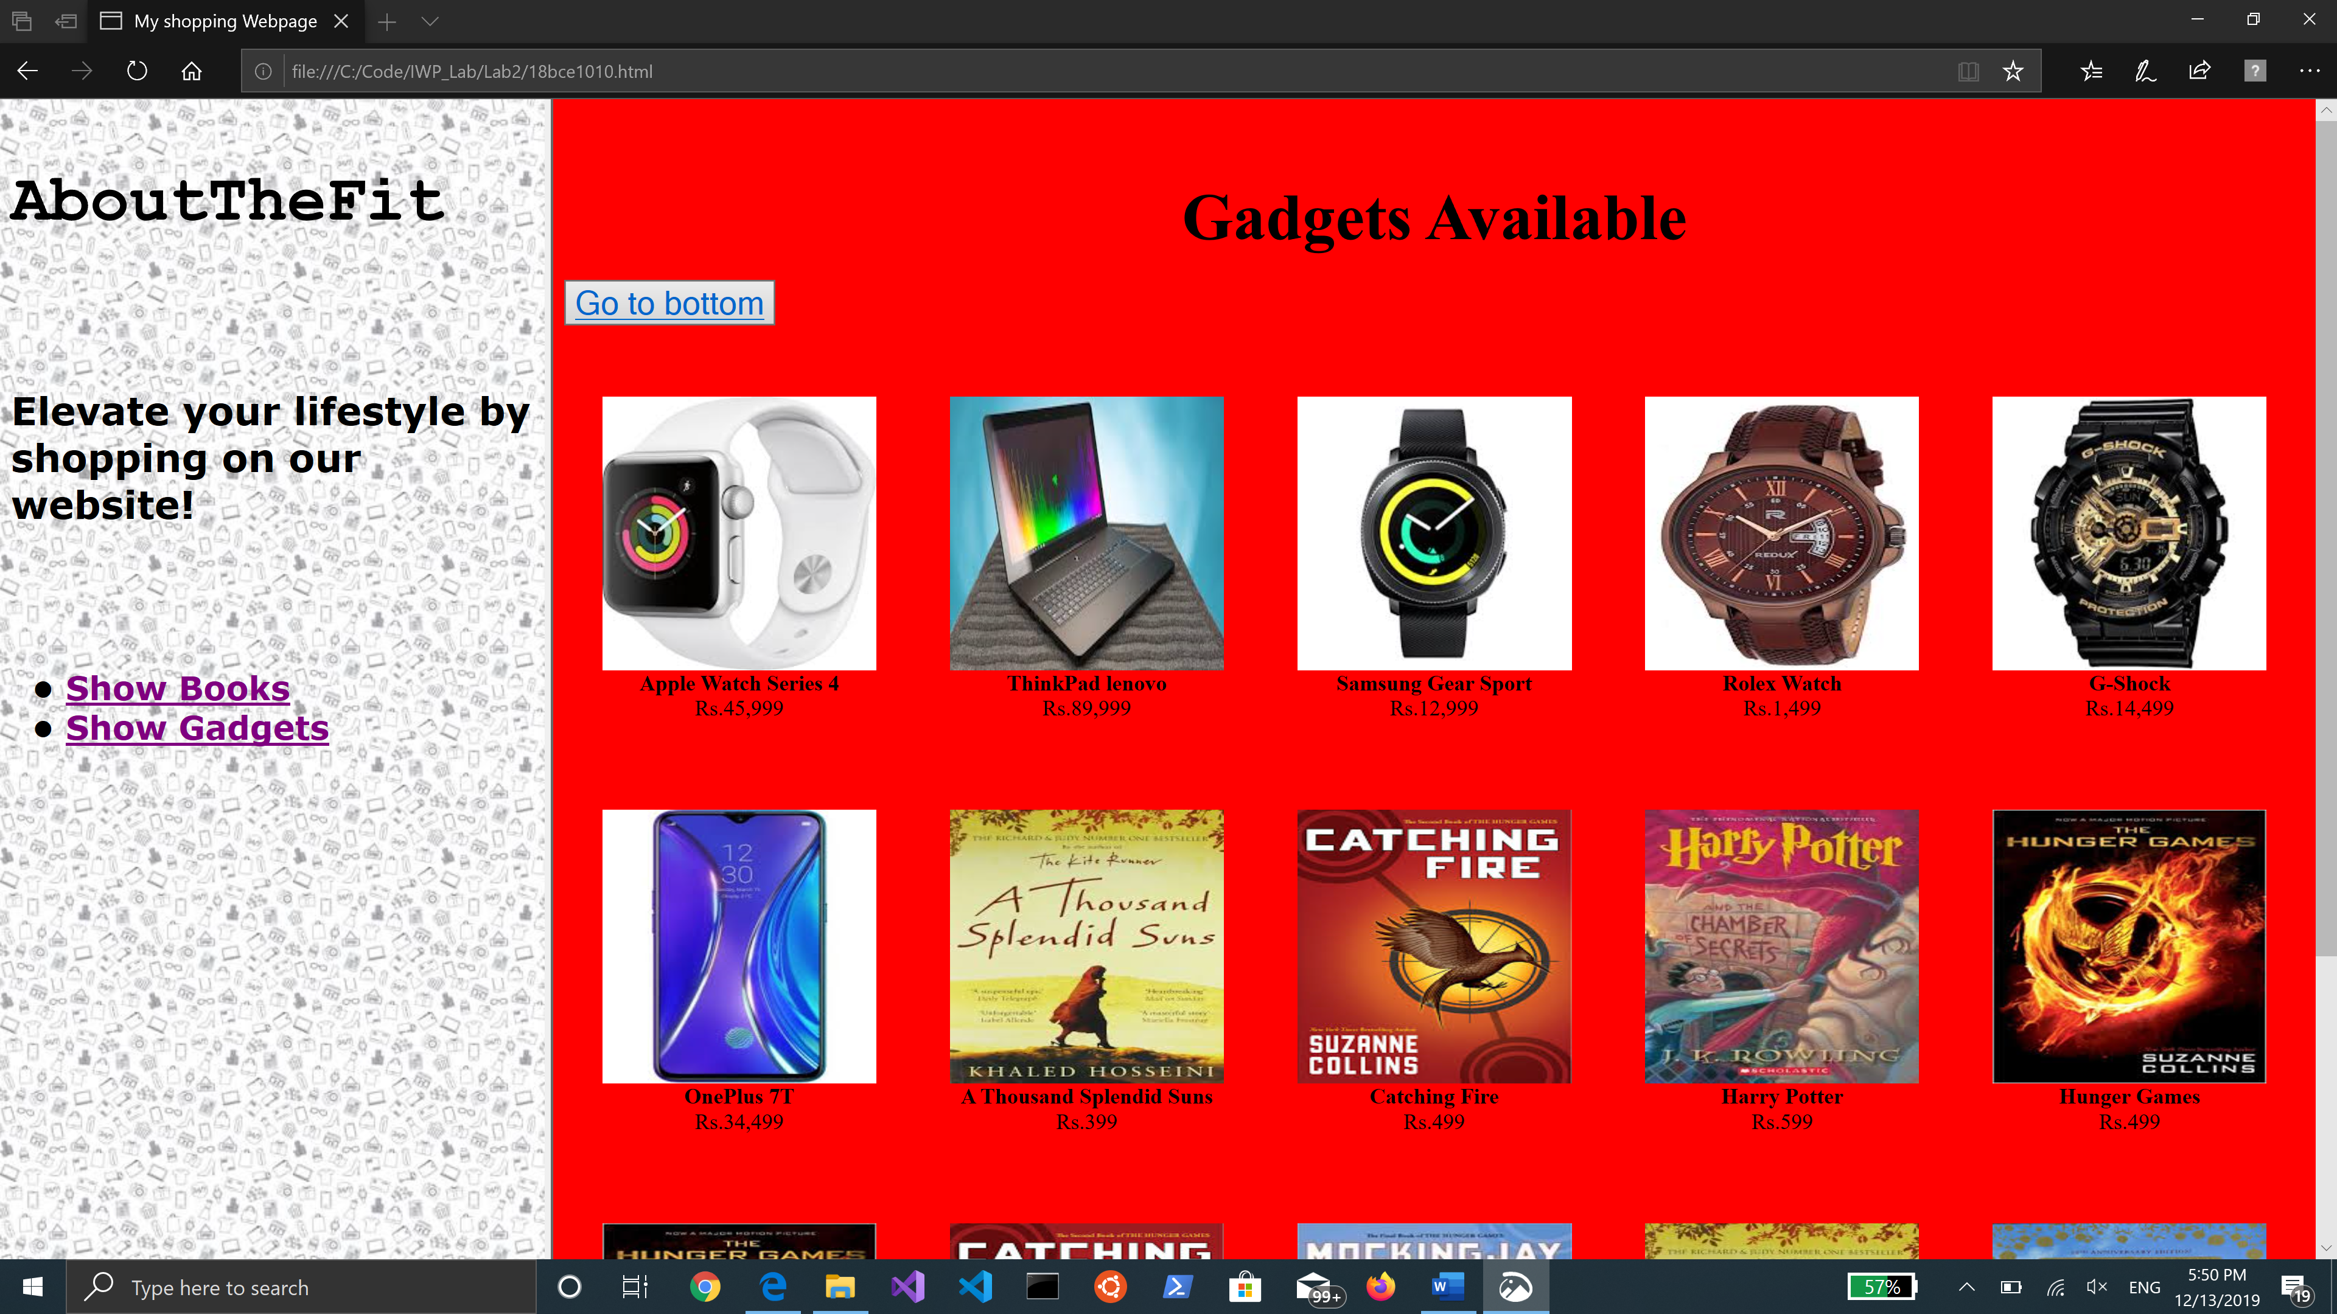

**Hovering and enlarging the photo:**

